22nd INTERNATIONAL PROBABILISTIC WORKSHOP – IPW 2026 - Instructions to prepare a full paper
A. Last Name¹, B. Last Name², …. (list all contributors)
¹ Department of Civil, Environmental and Architecture Engineering, University of Padova, via Francesco Marzolo 9, 35131, Italy
² Affiliation 2
Abstract. This document provides instructions for preparing full papers for the conference. In order to ensure uniform style, you should follow what is set below. The abstract should briefly state the main goals of the study, the principals results and conclusions derived.

Keywords: concise list of words of the main topics
- paper format
Full paper’s length should be no more of 8 pages and the abstract should have around 150-200 words. The main text must be written in English. Page size should be set to 210x297 mm (A4 by ISO 216 standard), with top and bottom margins of 2.5 cm and the outer margin to 2.0 cm. Page numbers should be included, starting from 1 at the first page. All texts in the paper should be written in Garamond.
  - First Page
The first page must contain Title, Author(s), Affiliation(s), Abstract and Keywords. The introduction Section must be placed after these. Title should follow the “01.Paper Title” format. Hence, it is centre aligned, with boldface Garamond in 18 pts and Title Case letters. Authors should be placed with a spacing of 18 pts after the Title. They are centre aligned, written in Garamond 12 pts, as specified in “02.Contributors” format. The author’s name should include the first letter of his First Name and Last Name in full. Author’s affiliation should be written in 11 pts Garamond and it should be left-aligned, providing: Institution/Company, City and Country separated with commas. Lastly, Abstract and Keywords should be written in 11 pts and a 12 pts should separate each other. Note that, the first line must begin with Abstract/Keywords rod boldfaced.
- Paragraph format
  - Headings
Headings should be properly numbered and they must be limited to three levels. For each one you should use the following formats:
- “05.Title_Lv1” should be applied to first level headline and it is 12 pts Garamond, left aligned, bold type, and uppercase . The spacing above is set up to 27 pts and below up to 9 pts
- “06.Title_Lv2” should be applied to second level headline and it is 12 pts Garamond, left aligned and bold. The spacing above is set up to 18 pts and below up to 9 pts
- “07.Title_Lv3” should be applied to third level headline and it is 12 pts Garamond, left aligned and italic type. The spacing above is set up to 18 pts and below up to 9 pts
    - Body Text
The body text should be written in Garamond, 12 pts, justified with no hyphenation. Moreover, it has to be 14 pts spaced.
- Figures and Tables
Figures and tables should be numbered consecutively in the order in which they are mentioned in the text. For this reason, they should be inserted near the point where they are mentioned.
Format “09.Figures&Tables” should be applied to figures and table captions.
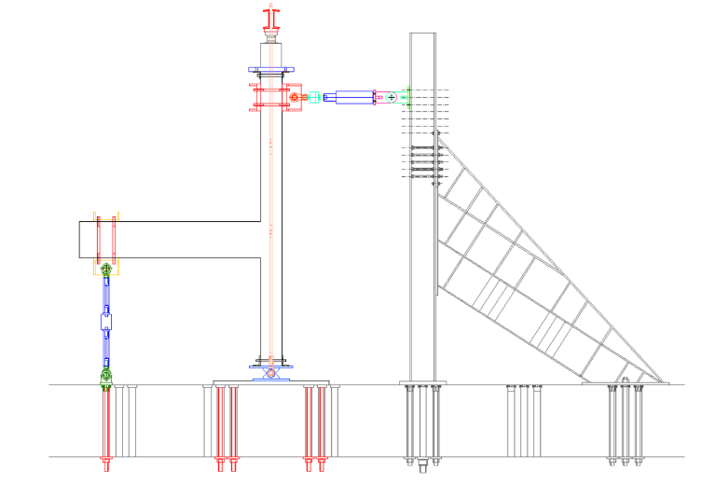
Figure.1 Description of the figure. If it contains more than an element, please define them with a), b), …
In order to achieve a good quality resolution, please use TIF format. A 600 dpi (dots per inch) resolution for line graph should be assigned, whereas a 300 dpi for bitmap figures should be sufficient. In addition, every additional element should be integrated with the figure and graphs should be no editable.
In the text, you should refer to figures or tables using Figure 1 or Table 1.
Table 1. Caption caption caption caption caption caption caption caption caption caption caption.
 | Mix Reference | Mix SLAG
Natural aggregates [kg] | 1804 | 990.66
EAF aggregates [kg] | - | 1141.75
Cement II A-L 42.5R [Kg] | 400 | 400
Water [l] | 180 | 180
w/c | 0.45 | 0.45
Water-reducing admixture [kg] | 4.0 | 4.8
- Equations
All the equations should be created by using the Microsoft Word equation editor. They should be left aligned and numbered. The number should be placed in brackets (°) and you should recall the equation in the text in this way. Equations format should be the same used for body text.
Format “10.Equations” should be used.
(1)
Text text text text text text text:
(2)
Text text text text text text text:
- References
Citations should be reported in the order which they are mentioned. They should be provided with a number put in square brackets [1], in a way that they can be cited along the text. Format “11.References” should be used. Example of references are given below:

- Gardoni P., Der Kiureghian A., and Mosalam K.M. (2002). Probabilistic capacity models and fragility estimates for reinforced concrete columns based on experimental observations. Journal of Engineering Mechanics, 128(10), 1024-1038.
- Mazzoni S., McKenna F., Scott M. H., Fenves G. L., and Jeremic, B. (2007). OpenSees command language manual. Pacific Earthquake Engineering Research Center. University of California, Berkeley.
- Santa U., Bergmeister K. and Strauss A. (2004). Bauwerksüberwachung der Autobahnbrücke Gossensaß. Beton‐und Stahlbetonbau, 99(12), 975-984.
- Zanini M.A., Faleschini F. and Pellegrino C. (2017). Probabilistic seismic risk forecasting of aging bridge networks. Engineering Structures, 136, 219-232
- Zanini M.A., Faleschini F., Ademovic N., Prendergast L.J., Gavin K. and Limongelli M P. (2017). Structural Health Monitoring and Design Code compliance for performance assessment of bridges under scour and seismic hazards. In Joint workshop COST TU1402, COST TU1402, IABSE (pp. .3-1-3.3-10).

