22nd INTERNATIONAL PROBABILISTIC WORKSHOP – IPW 2026 - Instructions to prepare EXTENDED ABSTRACT
A. Last Name¹, B. Last Name², …. (list all contributors)
¹ Department of Civil, Environmental and Architecture Engineering, University of Padova, via Francesco Marzolo 9, 35131, Italy
² Affiliation 2
Keywords: concise list of words of the main topics
- Extended abstract format
Extended abstract format’s length should be no more of 2 pages. A maximum of 2 figures/tables and 5 references may be included. The main text must be written in English. Page size should be set to 210x297 mm (A4 by ISO 216 standard), with top and bottom margins of 2.5 cm and the outer margin to 2.0 cm. Page numbers should be included, starting from 1 at the first page. All texts in the paper should be written in Garamond.
  - Figures/Tables
Figures/tables should be numbered consecutively in the order in which they are mentioned in the text. For this reason, they should be inserted near the point where they are mentioned.
Format “09.Figures&Tables” should be applied to figures and table captions.
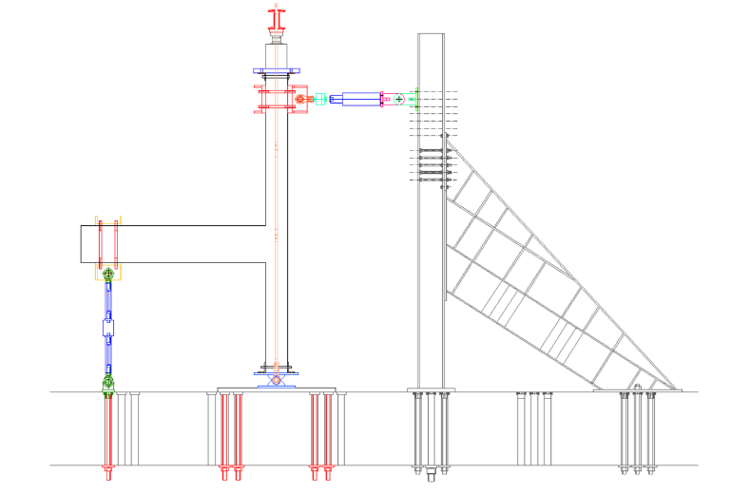
Figure.1 Description of the figure. If it contains more than an element, please define them with a), b), …
In order to achieve a good quality resolution, please use TIF format. A 600 dpi (dots per inch) resolution for line graph should be assigned, whereas a 300 dpi for bitmap figures should be sufficient. In addition, every additional element should be integrated with the figure and graphs should be no editable.
In the text, you should refer to figures or tables using Figure 1 or Table 1.
Table 1. Caption caption caption caption caption caption caption caption caption caption caption.
 | Mix Reference | Mix SLAG
Natural aggregates [kg] | 1804 | 990.66
EAF aggregates [kg] | - | 1141.75
Cement II A-L 42.5R [Kg] | 400 | 400
Water [l] | 180 | 180
w/c | 0.45 | 0.45
Water-reducing admixture [kg] | 4.0 | 4.8
- Equations
All the equations should be created by using the Microsoft Word equation editor. They should be left aligned and numbered. The number should be placed in brackets (°) and you should recall the equation in the text in this way. Equations format should be the same used for body text.
Format “10.Equations” should be used.
(1)
Text text text text text text text:
(2)
Text text text text text text text:
- References
Citations should be reported in the order which they are mentioned. A maximum of 5 references can be added. Example of references are given below:

- Gardoni P., Der Kiureghian A., and Mosalam K.M. (2002). Probabilistic capacity models and fragility estimates for reinforced concrete columns based on experimental observations. Journal of Engineering Mechanics, 128(10), 1024-1038.
- Mazzoni S., McKenna F., Scott M. H., Fenves G. L., and Jeremic, B. (2007). OpenSees command language manual. Pacific Earthquake Engineering Research Center. University of California, Berkeley.
- Santa U., Bergmeister K. and Strauss A. (2004). Bauwerksüberwachung der Autobahnbrücke Gossensaß. Beton‐und Stahlbetonbau, 99(12), 975-984.
- Zanini M.A., Faleschini F. and Pellegrino C. (2017). Probabilistic seismic risk forecasting of aging bridge networks. Engineering Structures, 136, 219-232
- Zanini M.A., Faleschini F., Ademovic N., Prendergast L.J., Gavin K. and Limongelli M P. (2017). Structural Health Monitoring and Design Code compliance for performance assessment of bridges under scour and seismic hazards. In Joint workshop COST TU1402, COST TU1402, IABSE (pp. .3-1-3.3-10).

